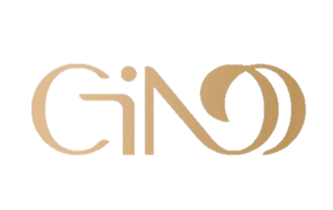
Gino International Co., Ltd.
1F., No.5, Alley2, Lane 101, Liao Ning St., Taipei, Taiwan, R.O.C.
Tel:886-2-2740-8929 Fax: 886-2-2752-3265
http://www.gino-cafe.com.tw Email:gino_service@yahoo.com.tw

Date :_________________________

Name: _______________________________________________________________

Delivery Address:_________________________________________________________

Email:________________________________________________________

Phone:________________________________

Carry-on Package
Item | Description | Price (NT$) | Quantity
Milk Tea | 16g X 32 Sachets | $240
Brown Sugar Bubble Tea | 70g X 5 Sachets | $240
Brown Sugar Milk Tea | 20g X 24 Sachets | $240
Goat Milk Tea | 20g X 22Sachets | $260
Jasmine Tea Latte | 20g X 20Sachets | $230
Uji Matcha Latte | 20g X 20Sachets | $245
Lavender Milk Tea | 20g X 20Sachets | $230
Imperial Instant Black Coffee | 2g X28Sachets | $270
3 In 1 Instant Coffee | 24g X 24Sachets | $260
2 In 1 Instant Coffee ( SugarFree) | 15g X18Sachets | $210
Hazelnut Flavored 3 In 1 Instant Coffee | 24g X16Sachets | $220
Blueberry Flavored Tea | 18g X 28Sachets | $215
Lemon FlavoredTea | 18g X18Sachets | $165
Brown Sugar Ginger Tea | 20g X 20Sachets | $220
Multi-Grain Cereal | 30g X 18Sachets | $230
Hazelnut Flavored Yam &Pearl Barley Cereal | 30g X 18Sachets | $230
Zip-lock Package
Item | Description | Price | Quantity
Milk Tea | 600g/Bag | $220
Brown Sugar Milk Tea | 500g/Bag | $220
Multigrain Cereal | 650g/Bag | $230
Hazelnut Flavored Yam &Pearl Barley Cereal | 650g/Bag | $230
Almond Powder with Crystal sugar | 500g/Bag | $335
Multi-Grain Cereal (SugarFree) | 650g/Bag | $260
Almond Powder (Sugar Free) | 500g/Bag | $375
Black Sesame Powder (Sugar Free)) | 500g/Bag | $225

